Inc. 5000 Top Companies Data Analysis

Industries With the Most Growth.

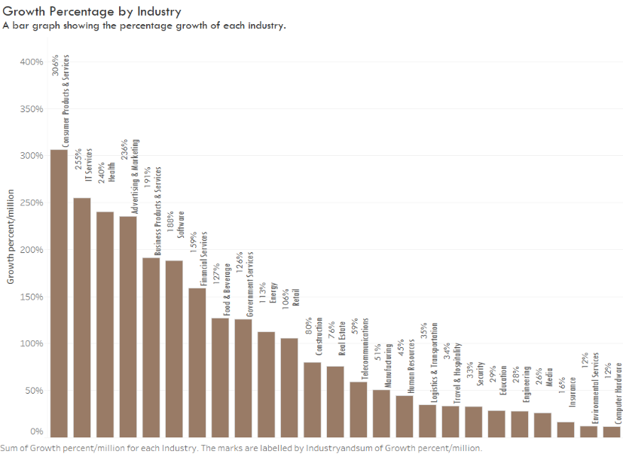

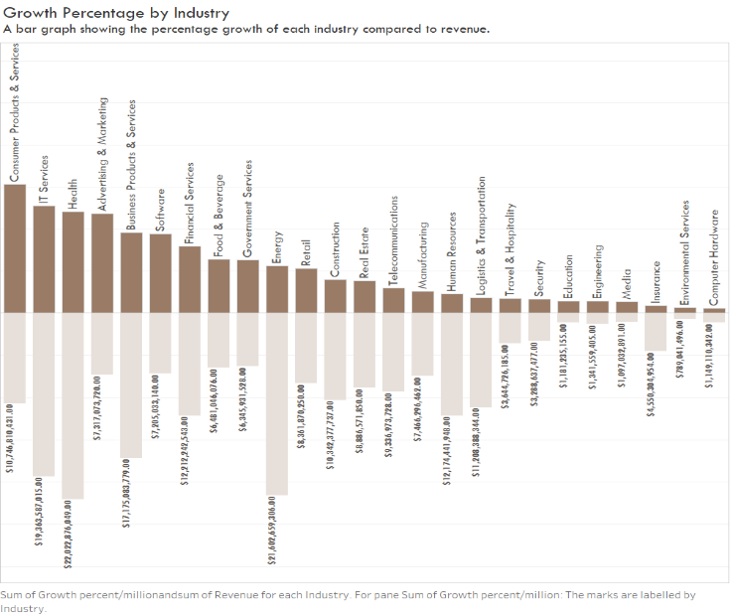

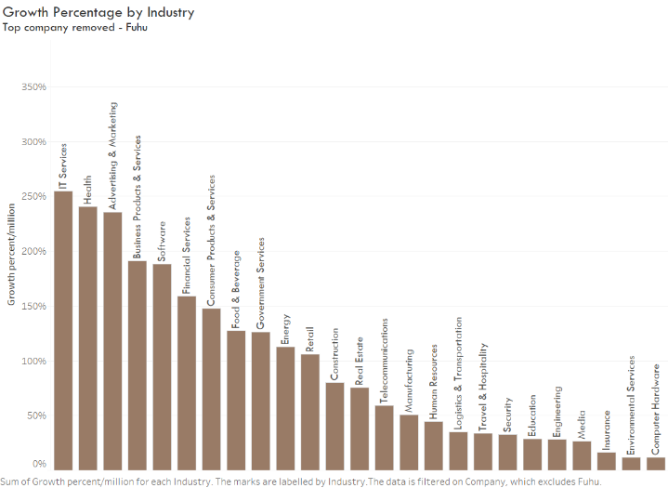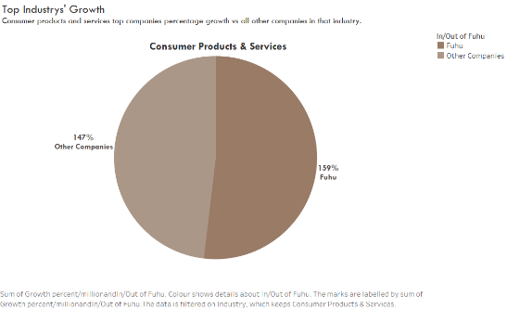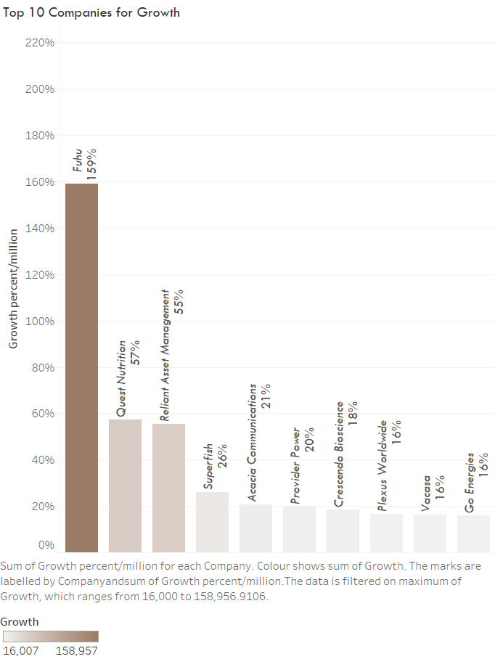

Figure 3 demonstrates that the impact of a company with a significantly higher growth percentage can impact the entire overview. The company **Fuhu**has an exceptionally high percentage growth at 159 million per cent, compared to the next company **Quest Nutrition**with 57 million per cent.

Figure 5 A Bar graph showing the percentage Growth of each industry with Fuhu removed.

Figure 4 is a pie chart to visually reinforce how much of an impact **Fuhu**has on the overall growth percentage. They make up over 50 per cent of the **Consumer Products & Services**industries' percentage growth which would take this industry out of the first place.

Figure 5 shows the industries' growth percentage without Fuhu. This graph shows that without **Fuhu, Consumer Products & Services**industry is ranked seventh instead of first in percentage growth. It could be argued that **IT Services**is the industry with the most significant growth per company.

Figure 1 shows that the industry that saw the most growth was **Consumer Products & Services**, with 306 million per cent growth, followed by**IT Services**, **Health**, and **Advertising & Marketing**, which had 255 million, 240 million, and 236 million per cent growth, respectively. Figure 2 Highlights the contrast between percentage growth and revenue, as the revenue of an industry does not correlate with the percentage growth of the industry.

Figure 1 Bar graph showing the Percentage Growth of each Industry

Figure 4 A Pie chart reinforcing figure 3

*Figure 3 A Bar Graph showing the Companies with the most Growth.*

Figure 2 Shows the Percentage Growth compared to the revenue of each Industry.

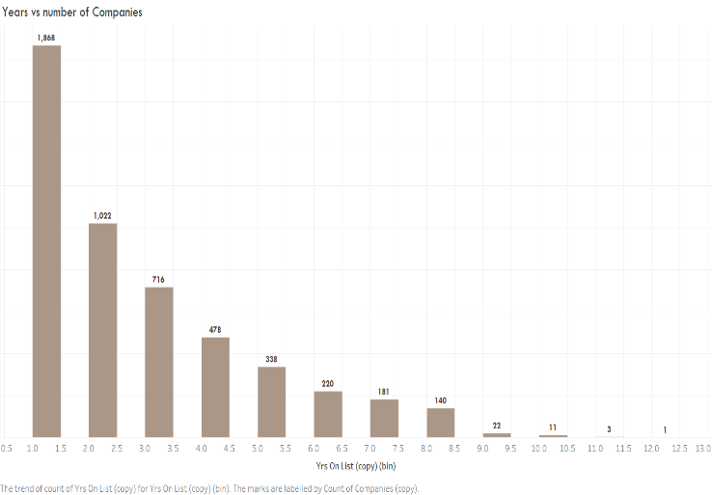

Do companies that have been on this list longer have a higher chance of appearing again in this list?

Figure 6 is a bar chart showing the count of companies on the list for each number of years. Meaning that 1,868 companies have been on the list for one year, 1,022 companies have been on the list for two years and so on.

From this visualisation, it appears it is much more likely to be on the list for one year. However, the majority of companies, 3,132, have been on the list for more than one year, whereas only 1,868 have been on the list for one year.

Figure 6 Count of companies by each year

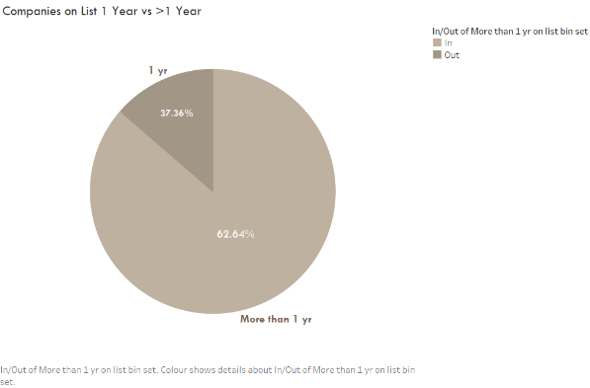

Figure 7 pie chart showing percentage of companies that have been on the list for one year vs more than one year

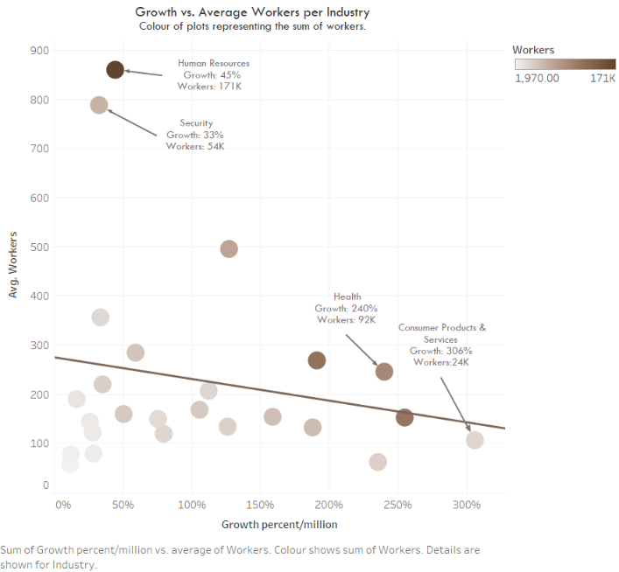 Does the number of workers in the company affect the growth of the company?

*Figure 8* shows a slight negative correlation between the number of workers and the percentage growth. This graph indicates that if there is any effect, the number of workers negatively affects growth; this may be because these companies with more workers have a greater outgoing than those with fewer workers.

The graph is coloured by the count of workers, with the least number of workers being the lightest and the darkest being the most. As you can see, the industry with the most workers is **Human Resources**, with 171 thousand workers and a percentage growth of 45 million per cent.

Does the number of workers in the company affect the growth of the company?

Figure 8 A Scatter Plot Graph Showing the Correlation between Count of Workers and Growth Percentage by Industry

*Figure 7*shows the percentages of companies that have been on the list for one year compared to the ones that have been on for more than one year in a pie chart.

However, the companies on this list must pay before actually being considered a place; this suggests that there is a specific type of company - *or companies run by a particular kind of person -* who would pay and apply to be on this list.

Therefore, the reason they are likely to reappear on the list may be more to do with the same people reapplying rather than a statistical probability, and thus working it out statistically with the limited information that you can find online would be redundant as you cannot find the number of companies who applied overall or information about US companies who had a more significant percentage growth, or revenue. Consequently, it is hard to say that the rankings are valid. That said, the companies must fulfil specific parameters before they are even considered for the list, so there is some validity within reason.

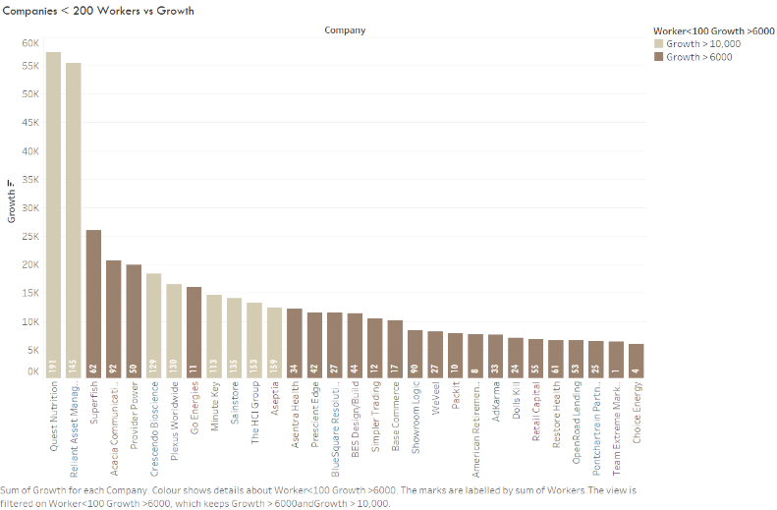

Figure 9 Shows the same Scatter plot as fig.6 With average workers capped at 300.

That said, Figure 9 demonstrates that if the average number of workers is 300, then there is a slight positive correlation between the count of workers and percentage growth. Although this still does not suggest anything significant. And the relation is marginal

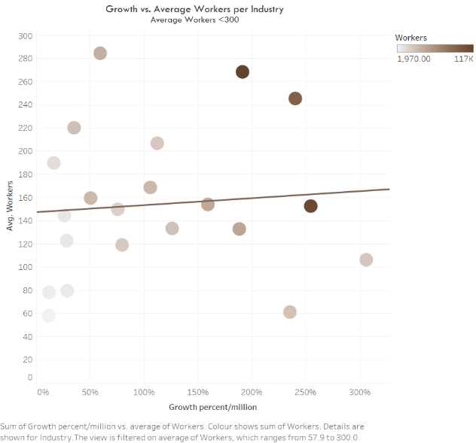

Figure 10 A bar graph showing the companies with less than 200 workers and their growth

*Figure 10*Highlights that having fewer workers does not mean that the growth will be less - these companies all had more than 6 thousand per cent growth. Ultimately, the p-value of 0.36 and 0.71 for *fig.6 and fig.7,*respectively, suggest that there is not a statistically significant relation between the count of workers and percentage growth.

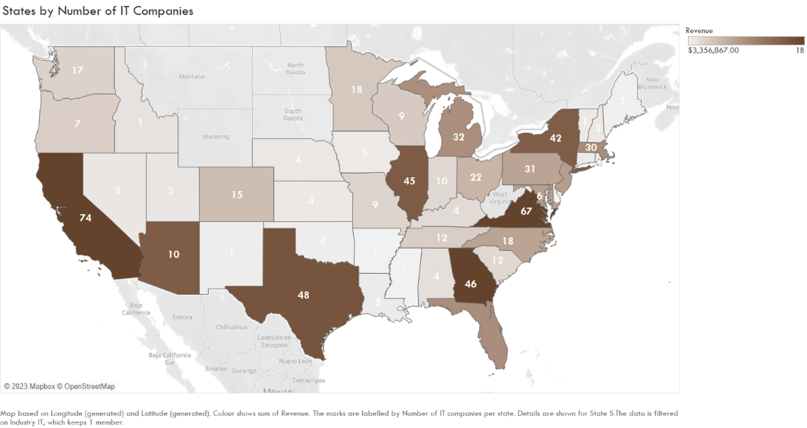Which state can you find most of the IT companies in?

Figure 11, a map of all the states with the number of IT companies labelled in each state, establishes that California has the greatest number of IT companies with seventy-four IT companies, followed by Virginia with sixty-four IT companies, succeeded by Texas, Georgia, Illinois, and New York have forty-eight, forty-six, forty-five, and forty-two IT companies respectively.

Figure 11 Map showing the number of IT companies by state

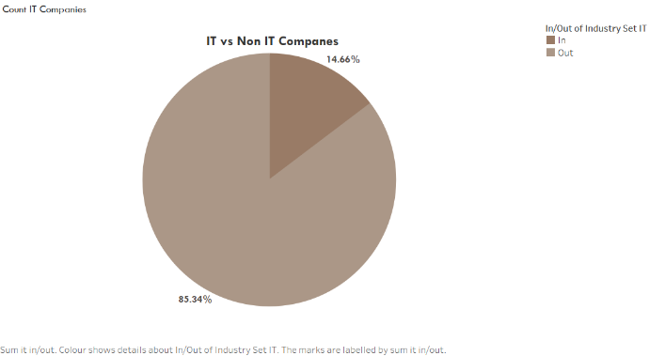

*Figure 12*shows all the states with the percentage of all the companies in each state that are IT companies.

This perspective shows a more objective representation of the distribution of IT companies. A state with a greater count of companies is likely to have more IT companies than a state with fewer overall companies. Using percentages to judge which state has the most IT companies may be more scientific as it accounts for context and allows for more scientific comparison between the states.

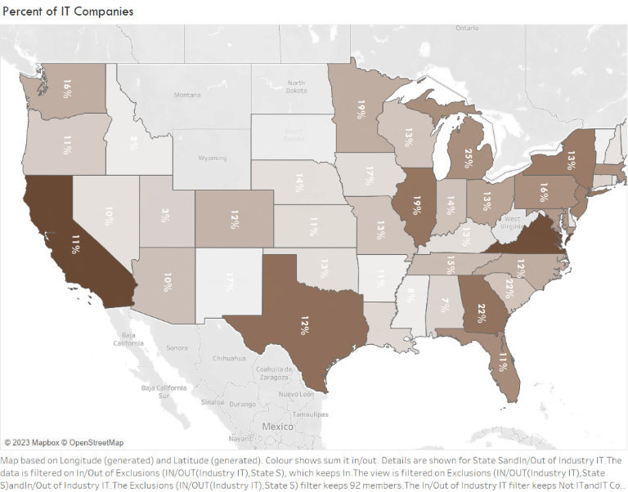

This map shows which state has a more significant proportion of IT companies out of their overall number of companies. Judging by the count may be less objective and make the data incomparable.

Figure 12 Map showing the percentage of IT companies per state.

Which cities have seen the most growth?

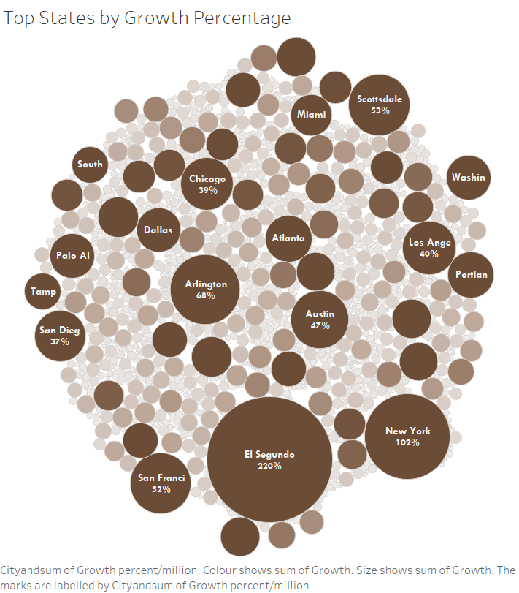

*Figure 13 Top cities based on overall percentage growth*

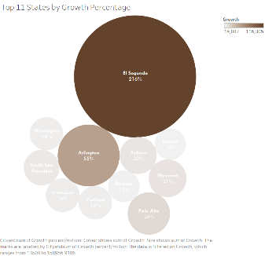

*Figure 13*is a bubble chart showing the cities by percentage growth. The largest bubbles represent the

with two-hundred and twenty million per cent, which is more than double of the succeeding city, New York, with one-hundred and two million per

cent, and then Arlington, with sixty-eight million per cent.

cities with the most significant percentage of growth. El Segundo is the city with the most growth,

Figure 14 Bubble graph showing cities and their percentage growth